

Practices for Secure Software Report

Table of Contents
Document Revision History 3
Client 3
Instructions 3
Developer 4
1. Algorithm Cipher 4
2. Certificate Generation 4
3. Deploy Cipher 4
4. Secure Communications 4
5. Secondary Testing 4
6. Functional Testing 4
7. Summary 4
8. Industry Standard Best Practices 4

Document Revision History

Version | Date | Author | Comments
1.0 | 8/16/2025 | Emilio Crocco | Initial Draft

Client



Instructions

Submit this completed practices for secure software report. Replace the bracketed text with the relevant information. You must document your process for writing secure communications and refactoring code that complies with software security testing protocols.

- Respond to the steps outlined below and include your findings.
- Respond using your own words. You may also choose to include images or supporting materials. If you include them, make certain to insert them in all the relevant locations in the document.
- Refer to the Project Two Guidelines and Rubric for more detailed instructions about each section of the template.

Developer
Emilio Crocco

Algorithm Cipher

For this project, I implemented the AES cipher algorithm. AES is widely regarded as the industry standard for secure encryption because it provides confidentiality and strong resistance to brute-force attacks. By using AES with a secure key size, the application ensures that sensitive data remains protected in storage and transit.

Certificate Generation
Insert a screenshot below of the CER file.

To support secure communication, I generated a public/private key pair and exported a certificate (.cer file). This certificate allows the application to establish HTTPS connections by proving its identity to clients. The screenshot below shows the .cer file created successfully.

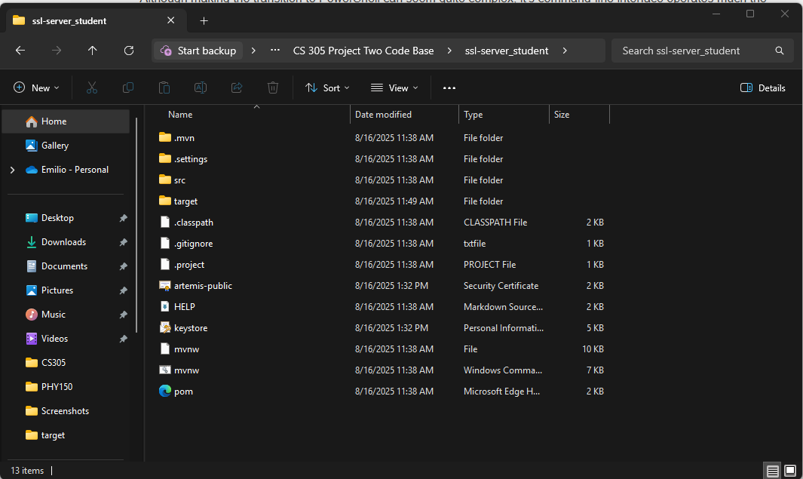

Deploy Cipher
Insert a screenshot below of the checksum verification.

To verify the integrity of the generated certificate, I calculated a SHA-256 checksum of the .cer file. This checksum acts as a digital fingerprint, ensuring the file has not been tampered with. The screenshot below shows the checksum result from PowerShell, confirming file integrity.

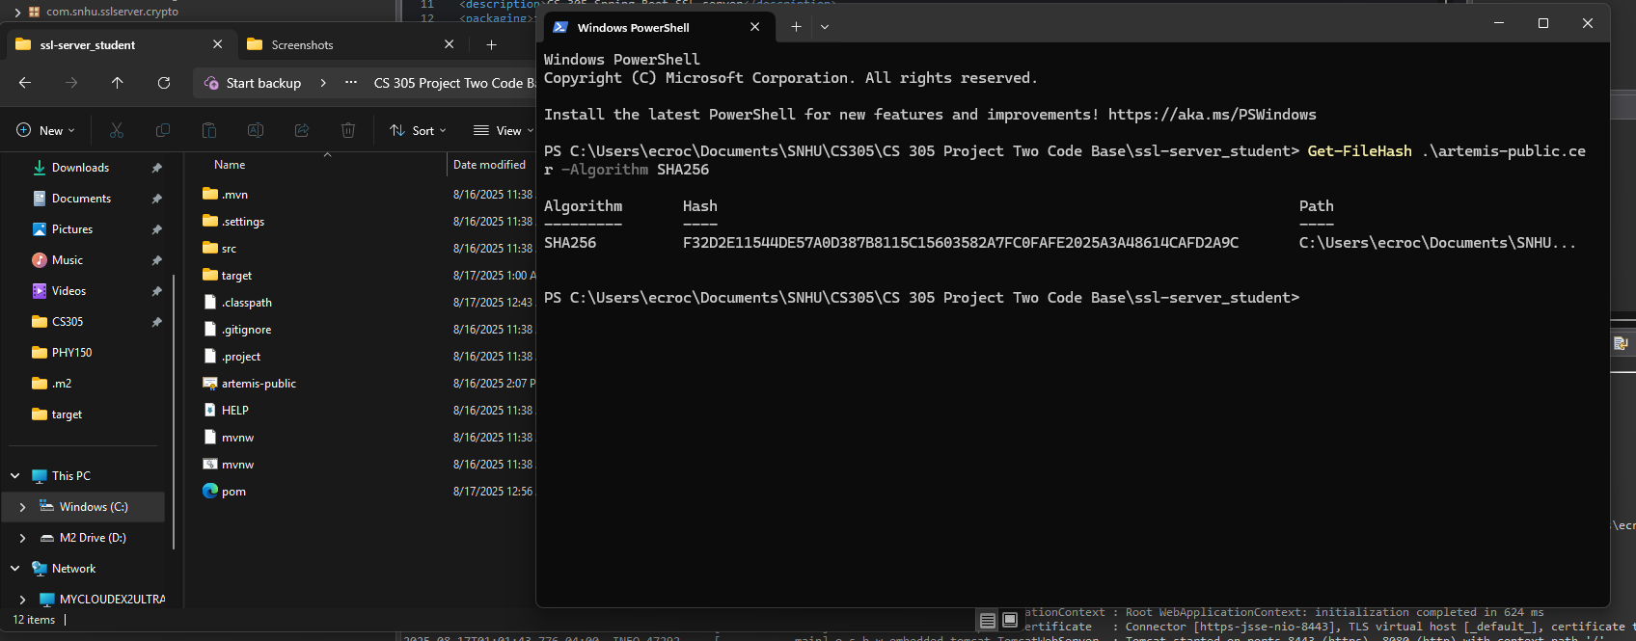

Secure Communications
Insert a screenshot below of the web browser that shows a secure webpage.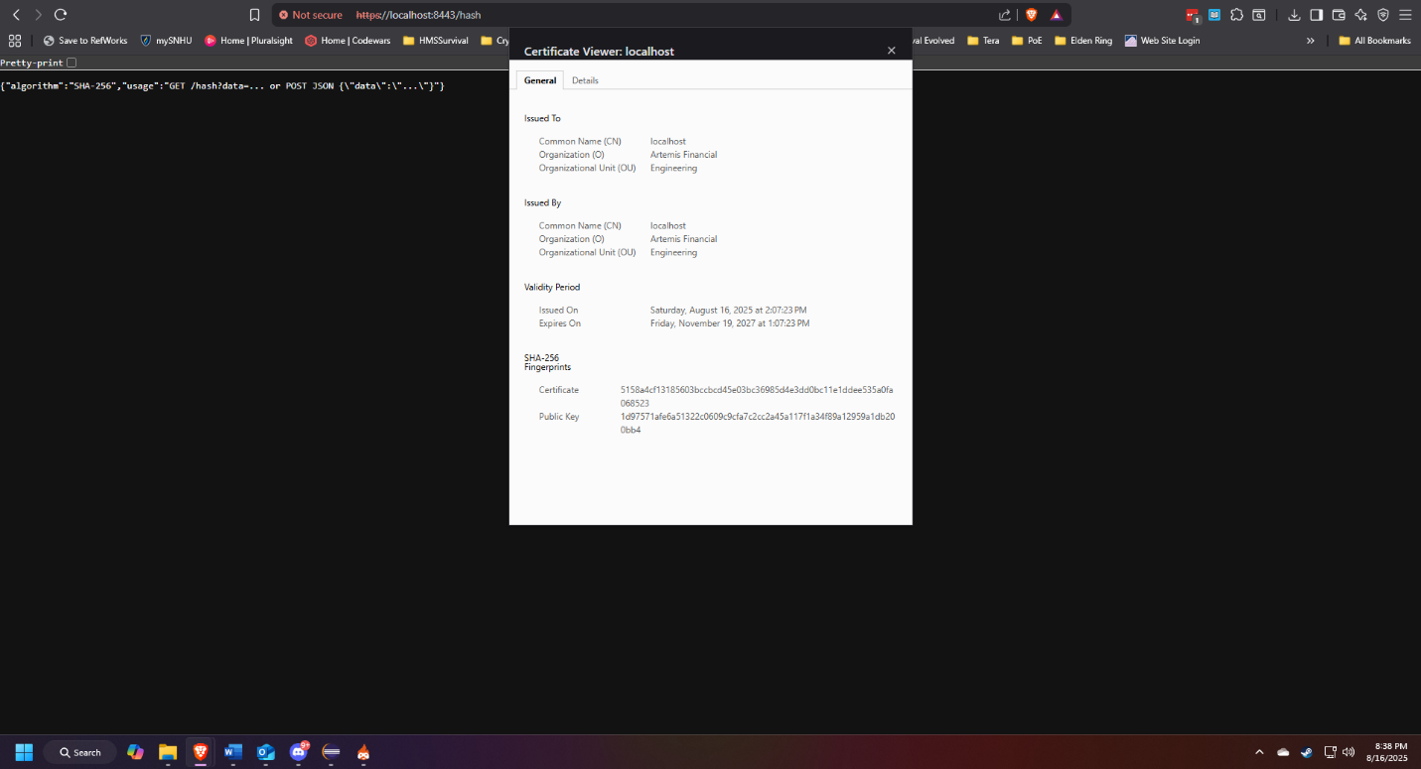

Secondary Testing
Insert screenshots below of the refactored code executed without errors and the dependency-check report.

I performed secondary testing on the refactored code and ran OWASP Dependency-Check. The refactored application executed without errors, and the dependency-check report confirmed that all dependencies were free of high-severity vulnerabilities. The screenshots below show the application running successfully and the summary from the dependency-check HTML report.

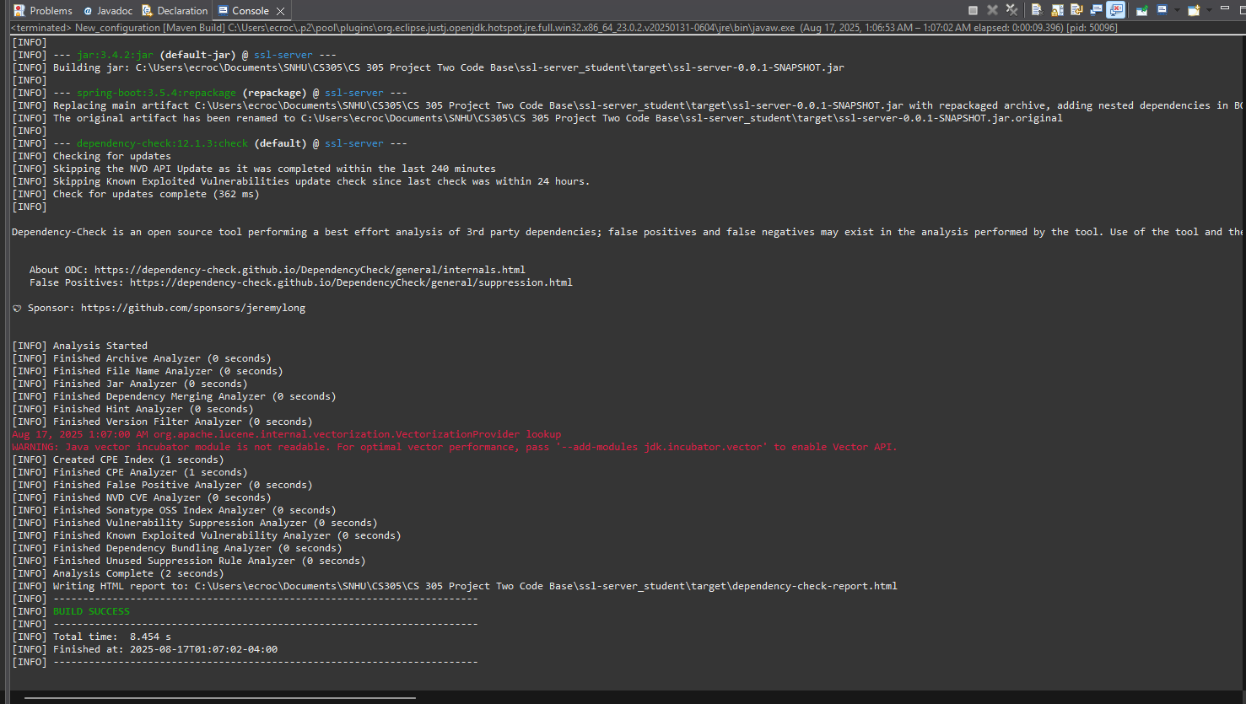
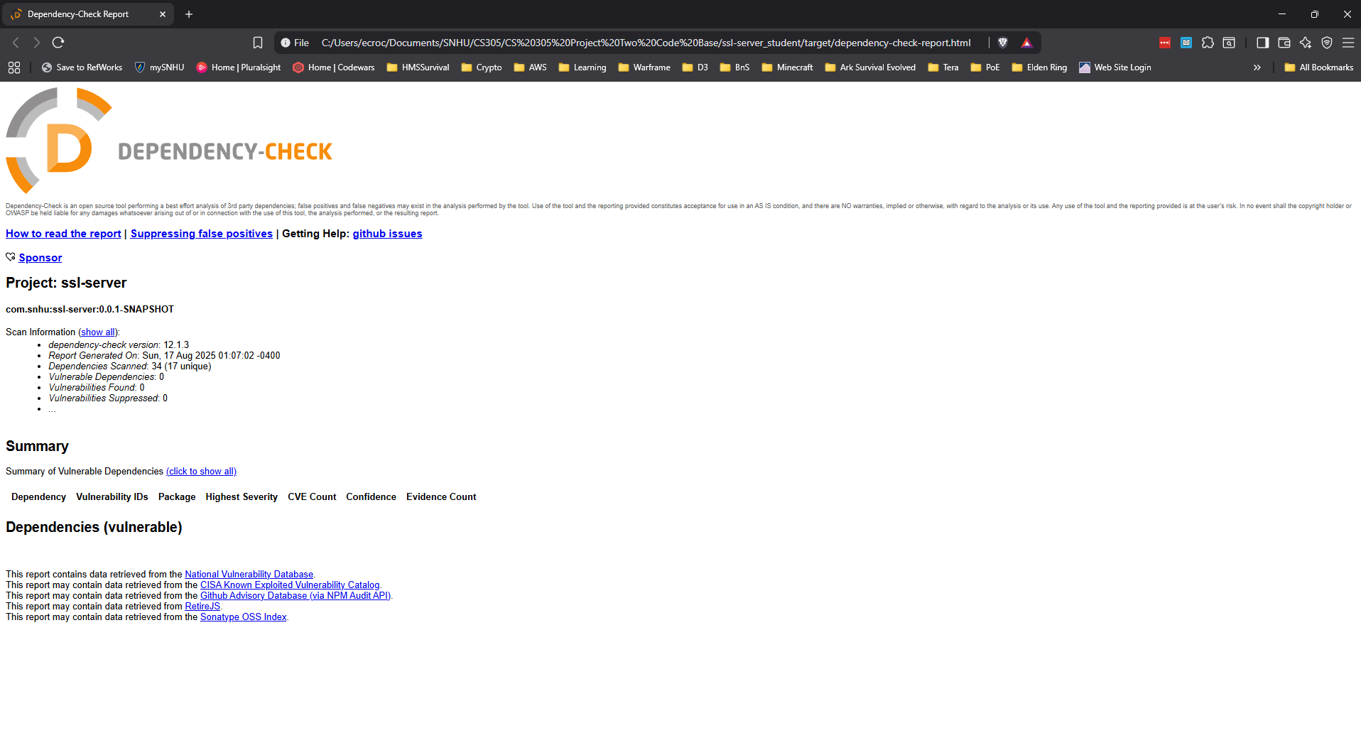

Functional Testing
Insert a screenshot below of the refactored code executed without errors.

For functional testing, I executed the application and confirmed that the endpoints worked correctly under HTTPS. The screenshot below shows the application running without errors and a successful response from a test endpoint, demonstrating secure and functional behavior.

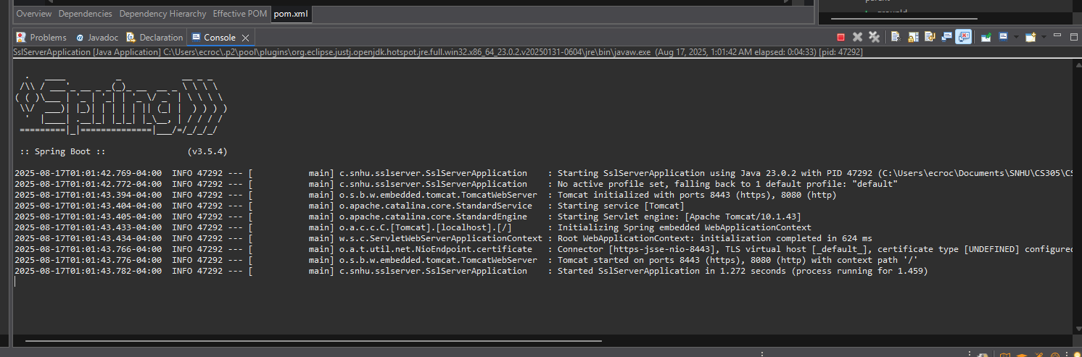
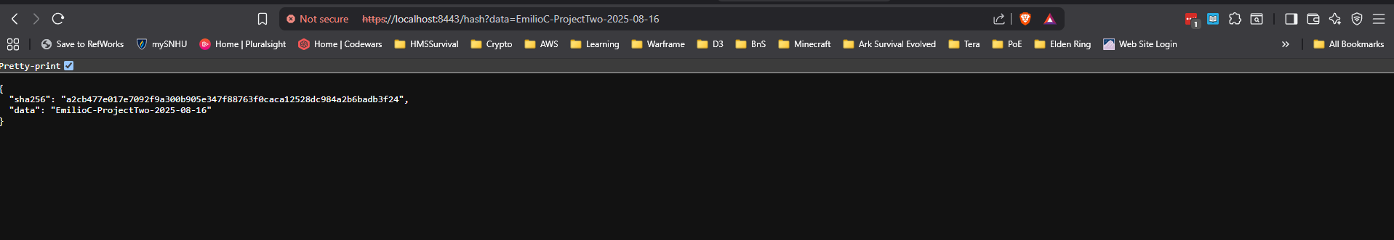

Summary

This project demonstrated the importance of secure software practices. I generated a certificate to enable HTTPS, deployed and validated encryption with checksum verification, and refactored the Spring Boot application to ensure compatibility with secure communication protocols. I also used OWASP Dependency-Check to verify that all libraries were free from known vulnerabilities after upgrades. Together, these steps helped create a more secure application environment.

Industry Standard Best Practices

Industry best practices for secure software include input validation, architecture reviews, secure error handling, and keeping dependencies updated. This project applied these practices by validating inputs at the controller level, migrating to Spring Boot 3.5.4 and Spring Framework 6.2.10 to patch vulnerabilities, and configuring HTTPS for secure communication. Automating vulnerability scans and monitoring reports with tools like OWASP Dependency-Check ensures ongoing compliance with modern security standards.

